Confidential Client Information for Minors
To save time, please supply the information below to the best of your ability. It is all covered by client confidentiality. However, if there is anything you do not wish to reveal at this time, please leave that space blank. When accessing this form from my website, you may print it out and bring it with you or attach it to an e-mail and send it to marklittman1@gmail.com. Please understand that sending information via email is not secure.

Please use back of sheet if necessary.

Referred by: _____________________________ Date__________________

Name of minor child: __ ______________________ Address: ______________________
___________________________________

Date of birth:___________________________

Parent information: Mother__________________________ Father_______________________
Email: ______________________________________
Phone: Home _____________Work_______________Cell_______________(ok to text? Y N)
I give permission for Mark Littman to identify himself to anyone answering the home phone Y N

Insurance
Insurance Company: ________________________________________________________________
Insurance ID #: _______________________________Group #: ______________________________ Name of Policy Holder: ________________________________ DOB of Policy Holder: __________

School

Current School ________________________________ Grade____________

Problems in school (please circle and explain on back of sheet)
Grades
Absenteeism or school refusal
Discipline
Bullying
Other

Employment Status

Is child employed? ☐Yes ☐No
Employer Name: _________________________________Type of job_________________
Length of employment_________________________

.

Emergency Contact Information
Name: ___________________________________________________________________________
Phone: ( ) _________________________ Relationship to minor: __________________________

Primary Care Physician of Child

Name of physician or practice __________________________________________________________________
Address: __________________________________________________________________________
Phone: ___________________________________________________________________________ Date: ______________

Presenting Problems and Concerns

Describe the problem that brought your child here today: (Use back of sheet if necessary)
_________________________________________________________________________________
_________________________________________________________________________________

Please check all of the behaviors and symptoms that you consider problematic:
☐Distractibility | ☐Change in appetite | ☐Suspicion/paranoia
☐Hyperactivity | ☐Lack of Motivation | ☐Racing Thoughts
☐Impulsivity | ☐Withdrawal from people | ☐Excessive energy
☐Boredom | ☐Anxiety/worry | ☐Wide mood swings
☐Poor memory/confusion | ☐Panic Attacks | ☐Sleep problems
☐Seasonal mood changes | ☐Fear away from home | ☐Nightmares
☐Sadness/depression | ☐Social discomfort | ☐Eating problems
☐Loss of pleasure/interest | ☐Obsessive thoughts | ☐Gambling problems
☐Hopelessness | ☐Compulsive behavior | ☐Computer Addiction
☐Thoughts of death | ☐Aggression/fights | ☐Self-harm behaviors
☐Frequent arguments | ☐Problems with pornography | ☐Parenting problems
☐Crying spells | ☐Irritability/anger | ☐Sexual problems
☐Loneliness | ☐Homicidal thoughts | ☐Relationship problems
☐Low self worth | ☐Flashbacks | ☐Work/school problems
☐Guilt/shame | ☐Hearing voices | ☐Alcohol/drug use
☐Fatigue | ☐Recurring, disturbing memories | ☐Visual hallucinations
☐Other: _______________

Are these problems affecting any of the following?
☐Handling everyday tasks ☐Self Esteem ☐Relationships ☐Hygiene
☐Work/School ☐Housing ☐Legal Matters ☐Finances
☐Recreational Activities ☐Health ☐Other

☐Yes ☐No Has the child ever had thoughts, made statements, or attempted to hurt him/herself? If yes, please describe: (include cutting and other self-harm behaviors)_________________________________

☐Yes ☐No Has the child ever had thoughts, made statements, or attempted to hurt someone else? If yes, please describe: ________________________________________________________________
Use back of sheet if necessary

Current members of household:
Name Relationship Age

Parents and siblings not living in household

Mother Age (if deceased, yr/cause

Father Age (if deceased, yr/cause

Siblings Age (if deceased, yr/cause

Other

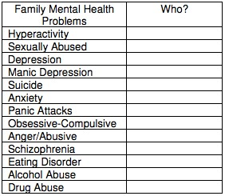
☐Parents legally married or living together
☐Parents temporarily separated
☐Parents divorced or permanently separated

Please check if child has experienced any of the following types of trauma or loss:
☐Emotional abuse |  | ☐Neglect | ☐Lived in a foster home
☐Sexual abuse |  | ☐Violence in the home | ☐Multiple family moves
☐Physical abuse |  | ☐Crime victim | ☐Homelessness
☐Parent substance abuse |  | ☐Parent illness | ☐Loss of a loved one (includes a pet)
☐Teen pregnancy |  | ☐Adoption issues | ☐ Other

Previous Mental Health Treatment_of Child

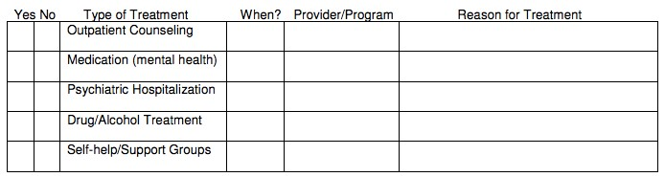

Substance Use History

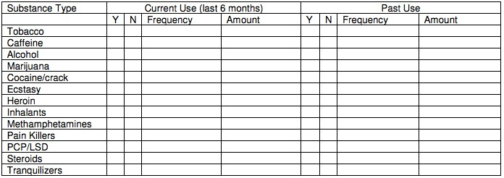

☐Yes ☐No Has there been withdrawal symptoms when trying to stop using any substances? If yes, please describe: _______________________________________________________________________
☐Yes ☐No Have there ever been problems with work, relationships, health, the law, etc, due to child’s substance use? If yes, please describe: _______________________________________________

Medical Information

Has child ever experienced any of the following medical conditions during his/her lifetime?
☐Allergies ☐Asthma | ☐Headaches ☐Stomach aches
☐Chronic pain ☐Surgery | ☐Serious accident ☐Head injury
☐Dizziness/fainting ☐Meningitis | ☐Seizures ☐Vision problems
☐High fevers ☐Diabetes | ☐Hearing problems ☐Miscarriage
☐Abortion ☐Sleep disorder  ☐Sexually transmitted disease | ☐Other: __________

Please list any CURRENT health concerns of child: ________________________________________

Current prescriptions medications: ☐None
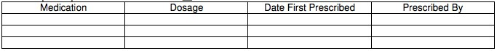
Allergies and/or adverse reactions to medications: ☐None
If yes, please list: ______________________________________________________________

Interpersonal/Social/Cultural Information
Please describe the child’s social support network
(check all that apply):
☐Family ☐Neighbors ☐Friends ☐Students ☐Co-workers
☐Support/Self help group ☐Community Group ☐Religions/Spiritual Center

Please describe child’s strengths, skills and talents?

_________________________________________________________________________________

_________________________________________________________________________________

Describe any special areas of interest or hobbies (art, books, physical fitness, etc): _______________

_________________________________________________________________________________

Legal Information

If the parents are separated or divorced, what is the current child custody/visitation arrangement?
_________________________________________________________________________________

Yes No | Is your child the subject of a custody case?
Yes No | Has your child ever been a ward of the court?
Yes No | Does your child have any legal offenses on record or pending in the courts?
Yes No | Has child ever been convicted of a misdemeanor or felony? If yes, please explain:
_____________________________________________________________________
Yes No Are you currently involved in any divorce or child custody proceedings? If yes, please explain: _______________________________________________________________

